Type-C to USB3 Inline Conversion Adapter
Easy, Plug n' Play USB3 conversion for your
Type-C only MacbookTM, WindowsTM and other Digital Devices

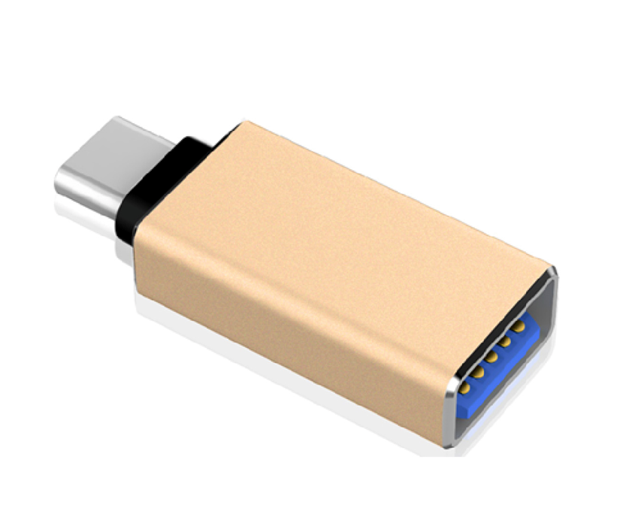

Descrption:

Look no further if you need to convert your Type-C only notebook, MacBookTM or other digital device to powerful, compatible USB3.

Simply plug into a vacant Type-C Port and connect your existing USB devices and peripherals. Also backward USB2 if needed.

Ideal for data transfer as well as charging devices with a current output up to 3 Amps, the stylish and robust design is fully Plug n' Play with almost all Type-C devices.

Specifications
- Material：Metal
- Transmission: USB3.0 14MB-16MB/S
- Compatibility: USB Type-C Female to MicroUSB Male
- Certificate: CE FCC ROHS
- Operating Temperature:0℃ to +45℃
- Operating Humidity:10%0 to 85 % RH
- Storage Temperature : -10℃ to +55℃
- Storage Humidity: 5% to 90 % RH

